**19CSE304: Foundations of Data Science**

**Assignment - 3**

**Name: Laxman K R**

**Roll: CB.EN.U4CSE20234**

**jury = {"Ethnicity":["Asian","Black","Latino","White","Other"],"Eligible":[0.15,0.18,0.12,0.54,0.01],"Panels":[0.26,0.08,0.08,0.54,0.04]}**

**jury**



Storing the data in a 2d-list

Alameda_df = pd.DataFrame(jury)

Alameda_df

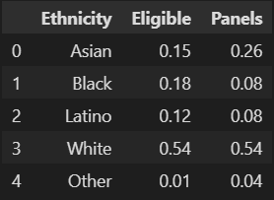

Saving the list as Dataframe

Alameda_df_1 = Alameda_df.set_index('Ethnicity')

Alameda_df_1

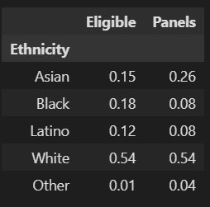

Setting Index for better visualization.

Alameda_df_1.plot.barh()

plt.ylabel('Ethnicity')

plt.gca().invert_yaxis()

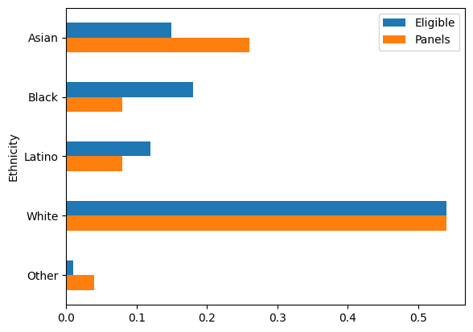

The difference between Eligible and panels

Alameda_df_1['jury_with_diffs'] = Alameda_df_1['Panels']-Alameda_df_1['Eligible']

Alameda_df_1

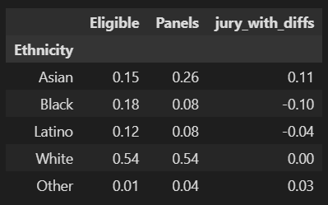

The difference between Eligible and Panels

Sum(jury_with_diffs)=0

Because the gain of the panel is exactly equal to the loss in the panel.

Alameda_df_1['Abs.Difference']=abs(Alameda_df_1['jury_with_diffs'])

Alameda_df_1

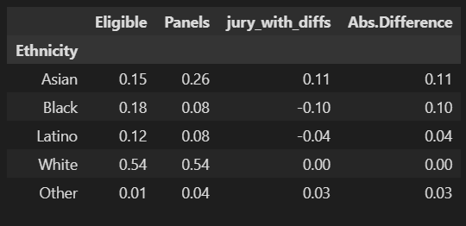

Calculating the Abs difference

test_statistic = Alameda_df_1['Abs.Difference'].sum()/2

test_statistic

0.14

Alameda_df_2['Random Sample'] = npr.multinomial(1453,[0.15,0.18,0.12,0.54,0.01])/1453

Alameda_df_2

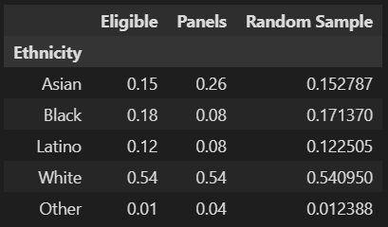

Taking Random sample with given eligibility

Alameda_df_2.plot.barh()

plt.ylabel('Ethnicity')

plt.gca().invert_yaxis()

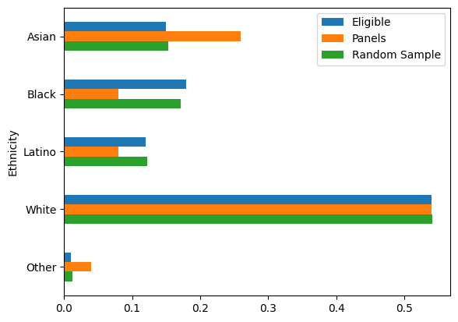

The green bars are closer in size to the blue bats than the orange bars.

TVD = (abs(Alameda_df_2['Eligible']-Alameda_df_2['Random Sample'])).sum()/2

TVD

0.00863041982105983

The difference between Eligible and Random Sample is very insignificant.

simulations = 5000

tvd_list=[]

for i in np.arange(simulations):

Alameda_df_2["Random Sample"]=(npr.multinomial(1453,[0.15, 0.18, 0.12, 0.54, 0.01]))/panel_size

tvd_list.append(table_tvd(Alameda_df_2, 'Eligible', 'Random Sample'))

tvd_final_df=pd.DataFrame(tvd_list)

tvd_final_df.rename(columns={0:"TVD"},inplace=True) # renaming column

tvd_final_df.head()

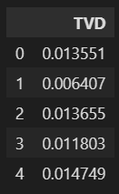

Ran 5000 simulations containing a list of 5000*5 random entries.

tvd_final_df.hist(bins=np.arange(0,0.2,0.005))

plt.ylabel('Percent per unit')

plt.xlabel('TVD')

plt.scatter(observed_stat, 0, color='red', s=30)

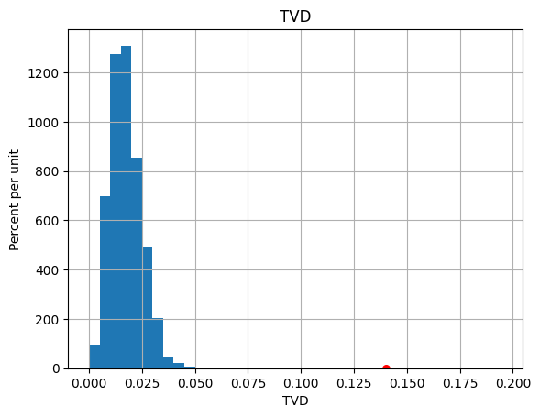

This percentage vs TVD shows the majority of them have a very low TVD value.

Since there is enough evidence of the Alternate hypothesis, we reject the Null hypothesis.